| **North South University**  Department of Electrical & Computer Engineering  **LAB REPORT-** 07  Course Code: *EEE111*  Course Title: *Analog Electronics*  Section: *06*  Lab Number: *07*  Experiment Name: *do not write anything here*  Experiment Date: *13th May 2023*  Date of Submission: 27*th May 2023*  Submitted by Group Number: 04  Group members: *(1st name must be of the one who has written the report)*   | Name | ID | Obtained Mark Simulation [5] | Obtained Mark Lab Report [15] | | --- | --- | --- | --- | | 1. Muhammad Raiyan Alam | 1831100642 |  |  | | 2. Sadia Tahasin | 1921397042 |  |  | | 3. Mosroor Mofiz Arman | 1921079642 |  |  | | 4. Md Shahidul Islam | 1822169642 |  |  |   Course Instructor: *Mohammad Shorif Uddin (MHUd)*  Submitted To: Md. Anisur Rahman Asif |
| --- | --- | --- | --- | --- | --- | --- | --- | --- | --- | --- | --- | --- | --- | --- | --- | --- | --- | --- | --- | --- |

*\*\*Erase everything that is in red & italics*

1. **Experiment name:** The BJT Biasing Circuits.
2. **Objective:** Study of the BJT Biasing Circuits
3. **Apparatus:**

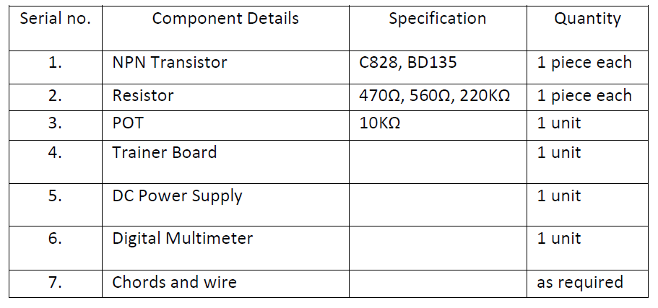

1. **Theory:**

Biasing a BJT circuit involves providing appropriate direct potentials and currents to establish an operating point or Q-point in the active region. The main objective of biasing is to choose a Q-point that faithfully reproduces the input signal. If the output signal is distorted, such as being clipped on one side, it indicates an unsatisfactory operating point that needs to be relocated on the collector characteristics. In laboratory settings, fixed bias and self-bias circuits are commonly studied. The fixed bias circuit determines the base current (IB) through the base resistance (RB), which remains constant. However, it can be unstable when the transistor's β value varies. To overcome this, the self-bias circuit utilizes a self-biasing resistor (RE) connected to the emitter terminal, addressing the instability issue.

1. **Circuit Diagram:**

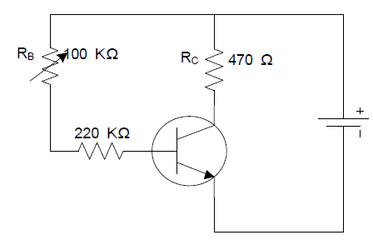

**Circuit - 01**

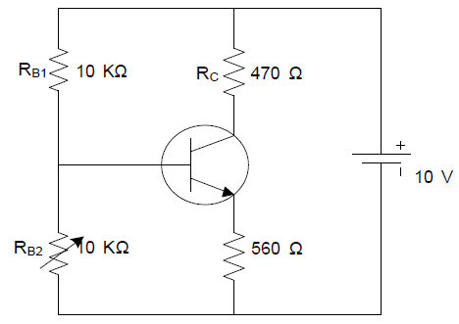

**Circuit - 02**

1. **Experimental Procedure:** 
   1. Build circuit - 01 using a C828 transistor. Set the value of RC (collector resistor) and adjust RB (base resistor) to its maximum value.
   2. Gradually decrease the value of POT RB while monitoring the circuit. Aim to achieve VCE (collector-emitter voltage) equal to VCC (supply voltage) divided by 2.
   3. Measure the voltage across RC and note down the value. Also, measure VCE and record it.
   4. Record the Q-point, which consists of the VCE and IC (collector current) values observed in step 3.
   5. Now, arrange the circuit as shown in circuit - 02 using a C828 transistor. Set the value of RC and adjust RB to its minimum value.
   6. Gradually increase the value of POT RB2 while monitoring the circuit. Again, target VCE equal to VCC divided by 2.
   7. Measure the voltage across RC and record it, along with the VCE value.
   8. Record the Q-point, which includes the VCE and IC values obtained in step 7.
   9. Replace the C828 transistor with a BD135 transistor and repeat all the steps starting from the beginning.
2. **Results:** In the lab, we did theoretical analysis base on the mathematical equation and predicted what might be the answer. In simulation, we analysed the circutal behaviour. Practical results are obtained through real-world implementation of the biasing circuits and direct measurements.

Based on all the activity that we have done, we can conclude the IV characteristics of the BJT circuits.



**Figure:** IV Characteristics of BJT Circuits

1. **Questions and Answers (Q/A):**

**Answer 01:** Stability Comparison:

To determine which circuit has better stability based on the given Q-points, we need to compare the variations in the Q-point values between the two circuits.

**In Circuit 01:**

Q-point: VCE = 4.97V, IC = 0.0106A

**In Circuit 02:**

Q-point: VCE = 5.71V, IC = 0.0123A

To assess stability, we need to consider the consistency of the Q-point values across different operating conditions or component variations. If the Q-point values are relatively stable and consistent, it indicates better stability.

From the given Q-point values, we can observe that Circuit 02 has a higher collector-emitter voltage (VCE) and collector current (IC) compared to Circuit 01. This indicates that Circuit 02 operates at a higher level, which may be due to a different biasing configuration or component values.

**Answer 02:** DC Load Line and Q-Point:

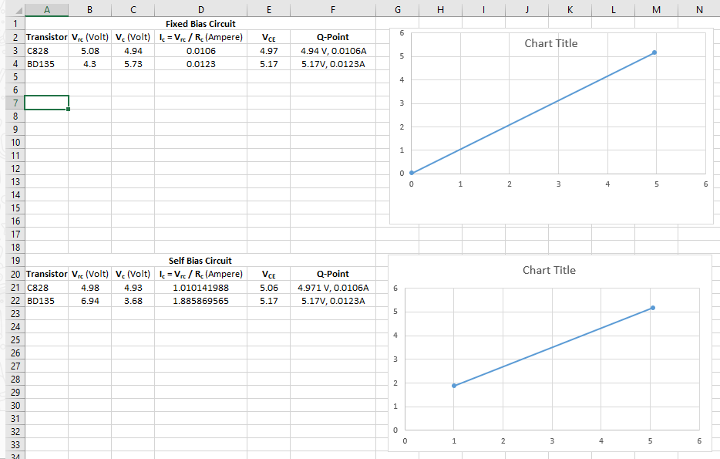

**Add:**

1. **Experimental Data Table:** In this section theoretical/computed, simulated, andmeasured/practical values should be shown in tabular form. All curves must bedrawn with suitable titles, units and scales on both axes.
2. **Discussion of Others**
3. **Simulation of Others**

**Discussion:** [Muhammad Raiyan Alam 1831100642](mailto:mdraiyan95@gmail.com)

Biasing a BJT circuit involves providing appropriate direct potentials and currents to establish an operating point or Q-point in the active region. The main objective of biasing is to choose a Q-point that faithfully reproduces the input signal. If the output signal is distorted, such as being clipped on one side, it indicates an unsatisfactory operating point that needs to be relocated on the collector characteristics. In laboratory settings, fixed bias and self-bias circuits are commonly studied. The fixed bias circuit determines the base current (IB) through the base resistance (RB), which remains constant. However, it can be unstable when the transistor's β value varies. To overcome this, the self-bias circuit utilizes a self-biasing resistor (RE) connected to the emitter terminal, addressing the instability issue.

**Simulation:**

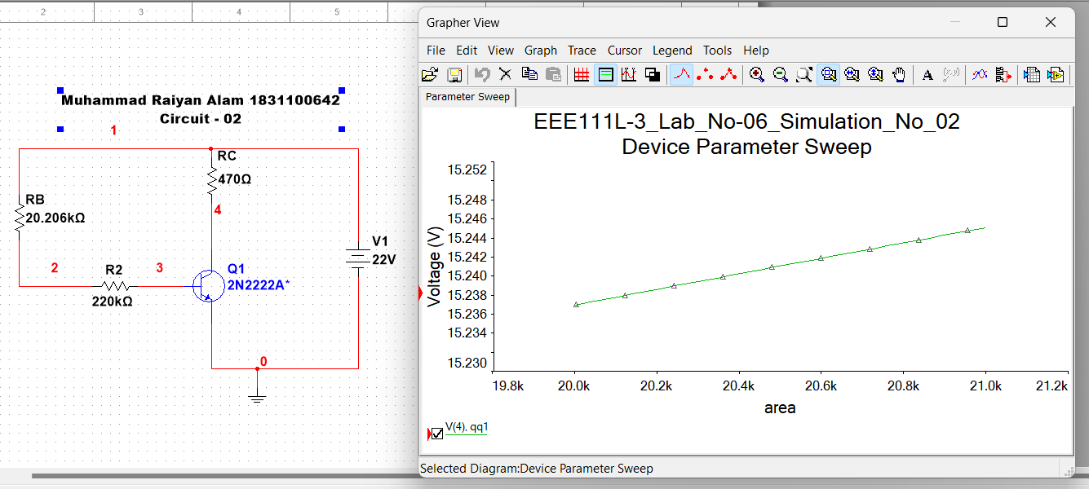

**Circuit - 01**

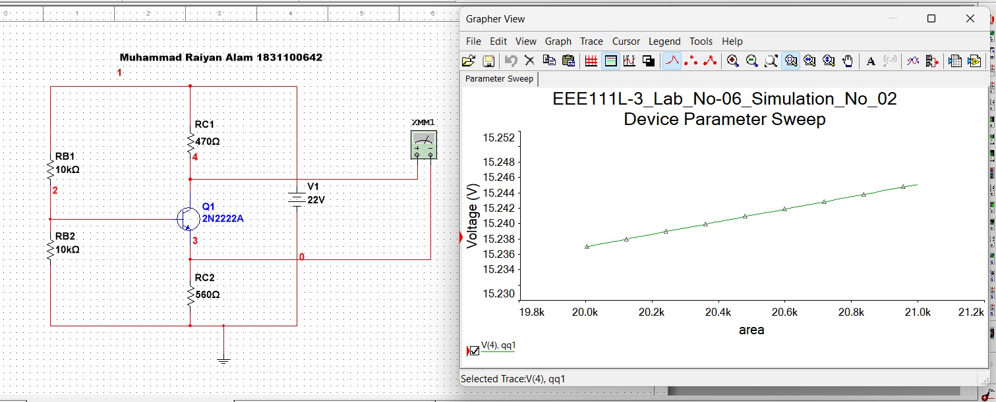

**Circuit - 02**